**Class 8 Home questions**

1. WAP to display the reverse of a number entered through keyboard.

Code:

#include <stdio.h>

int main()

{

    int i285,rem285,n285,div285;

    printf("Please provide the number you want to be reversed=>");

    scanf("%d",&n285);

    for(i285=1;i285<=n285;n285=n285/10)

    {

        rem285=n285%10;

        printf("%d",rem285);

    }

    return 0;

}

Output:

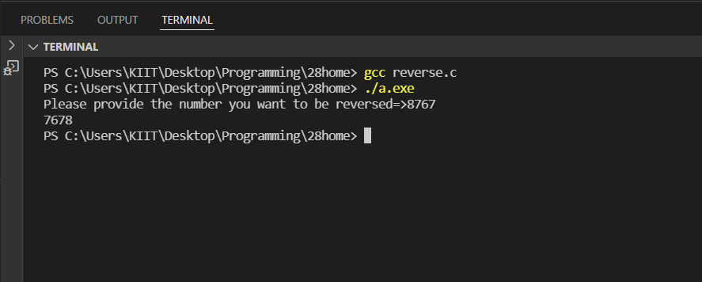

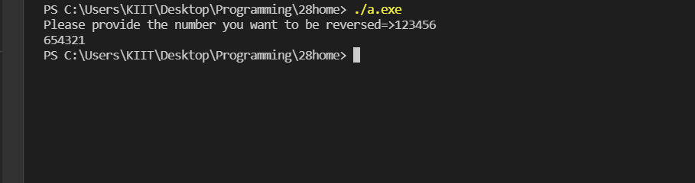

#2. WAP to check whether an integer number is a Armstrong number or not!.

Code:

#include <stdio.h>

#include <math.h>

int main()

{

    int i,sum,n,rem,globe,j,dummy;

    printf("Please provide a number to check if it is armstrong=>");

    scanf("%d",&n);

    globe=n;

    for(i=1;i<=n;n=n/10)

    {

        rem=n%10;

        sum= sum + pow(rem,3);

        if(sum==globe)

        {

            dummy=1;

            printf("yes %d is an armstrong number!\n",globe);

        }

    }

    if(dummy!=1)

    {

        printf("%d is not an armstrong number",globe);

    }

    return 0;

}

Output:

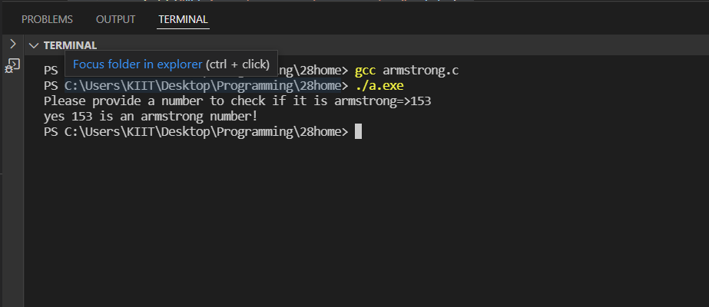

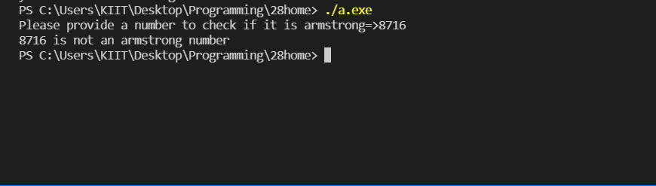

#3. WAP to print the following pattern for n r ows. Ex. for n=5 rows

A

B A

C B A

D C B A

E D C B A

Code: